

# AUGUST- 2023

**Programme : B.E / B. Tech**

**Course Code : CSA1190**

**Course Name** **: OBJECT ORIENTED ANALYSIS AND DESIGN**

**Date : 26-08-2023**

OOAD PRATICAL DAY 2 Marks:20

***11.AIM:-***To implement UML diagrams for Conference management system..

***DESIGN:***

1.USE CASE:

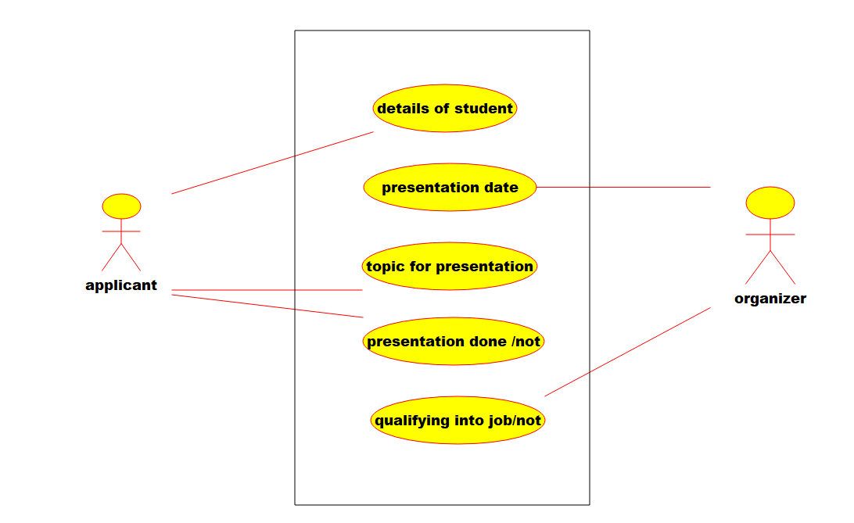

2.Deployment diagram:-

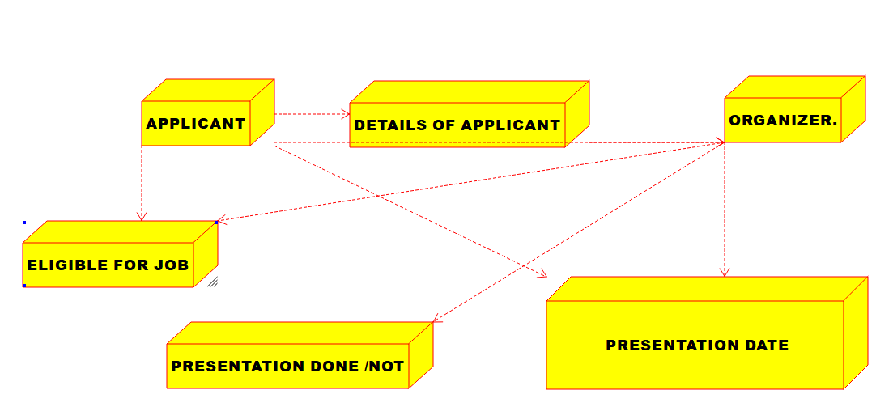

3.PACAKAGE DIAGRAM.:-

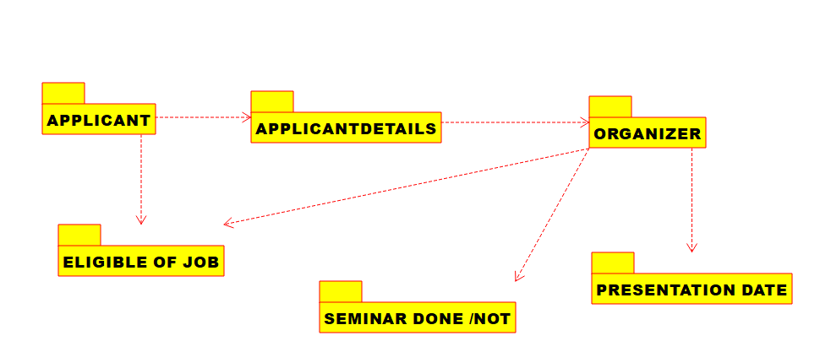

***12.AIM:-***To implement UML diagrams for Foreign Trading System..

DESIGN:-

1.SEQUENCE DIAGRAM:

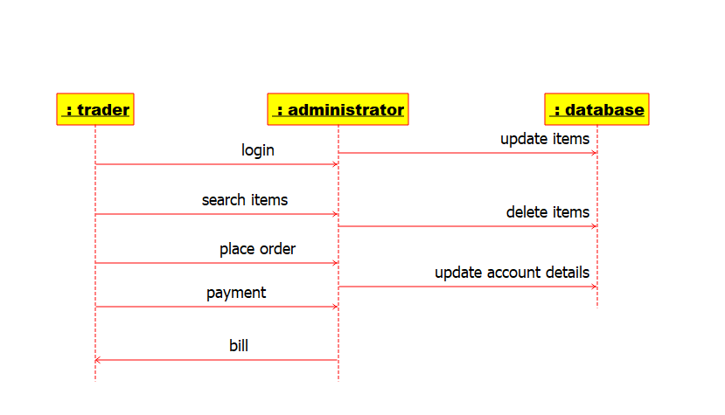

2.ACTIVITY DIAGRAM:-

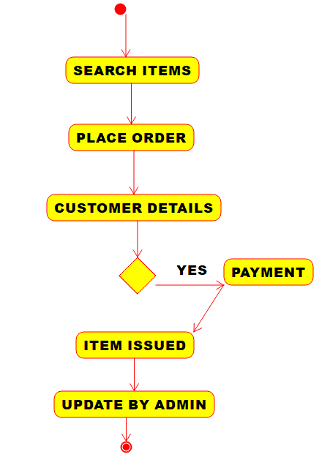

3.COMPONENT DIAGRAM:-

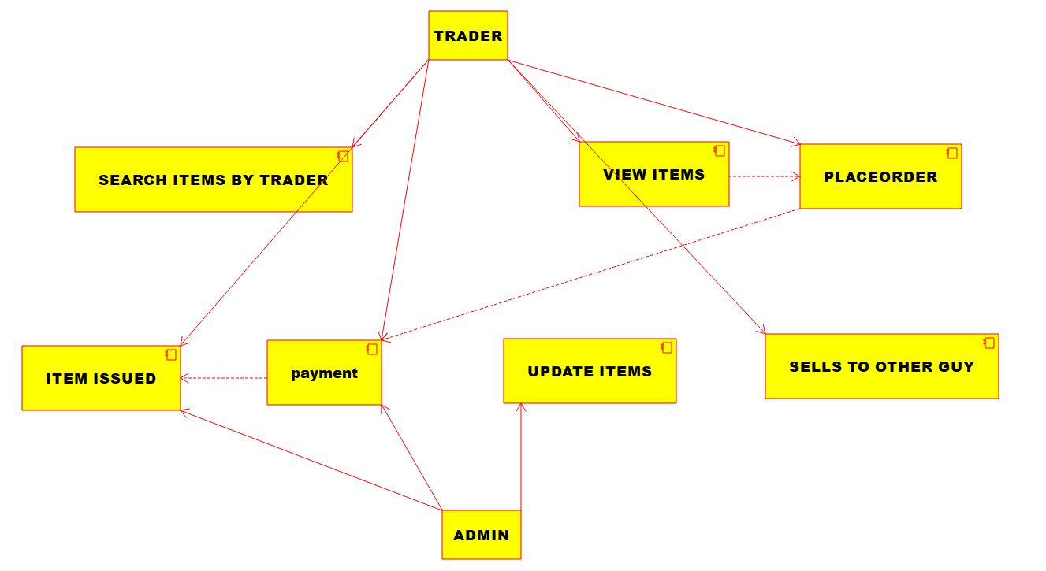

***13.AIM:-***To implement UML diagrams for BPO Management System..

***DESIGN:-***

1.ACTIVITY DIAGRAM:-

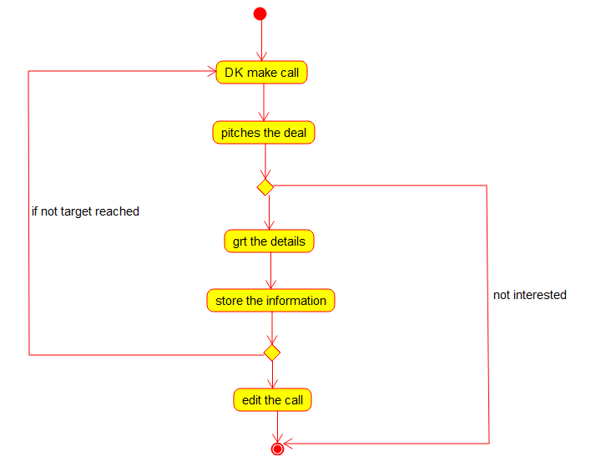

2.STATECHART DIAGRAM:-

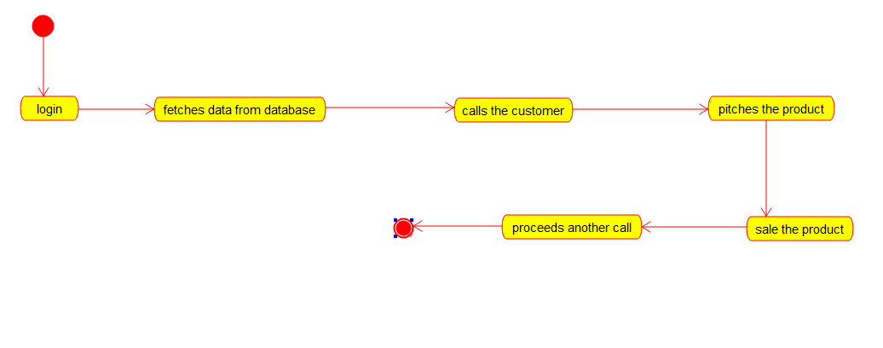

3.CLASS DIAGRAM:

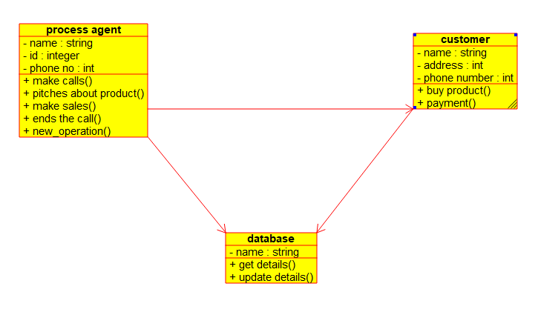

***14.AIM:-***To implement UML diagrams for E-Commerce Registration

***DESIGN:-***

1.ACTIVITY DIAGRAM:-

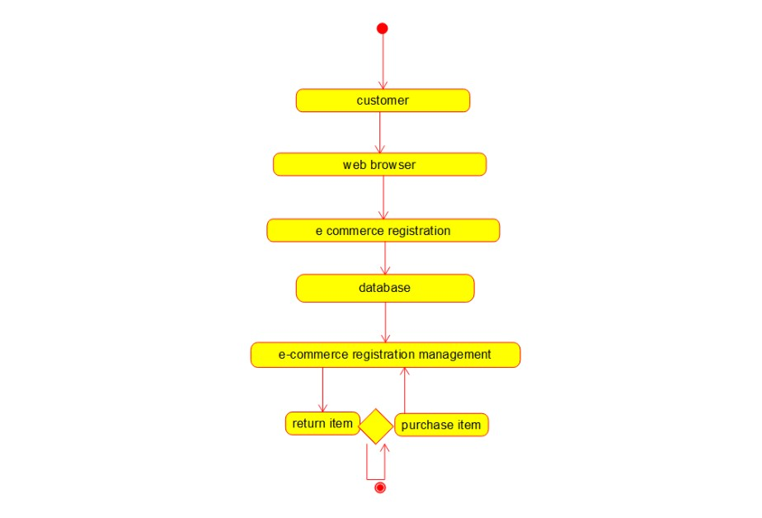

2.SEQUENCE DIAGRAM:-

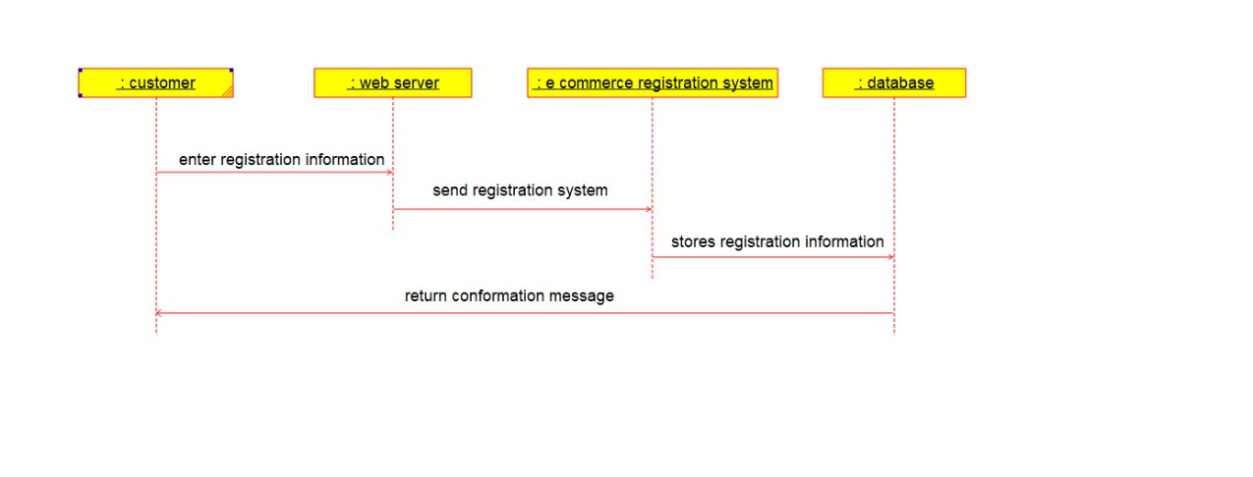

3.PACAKAGE DIAGRAM:-

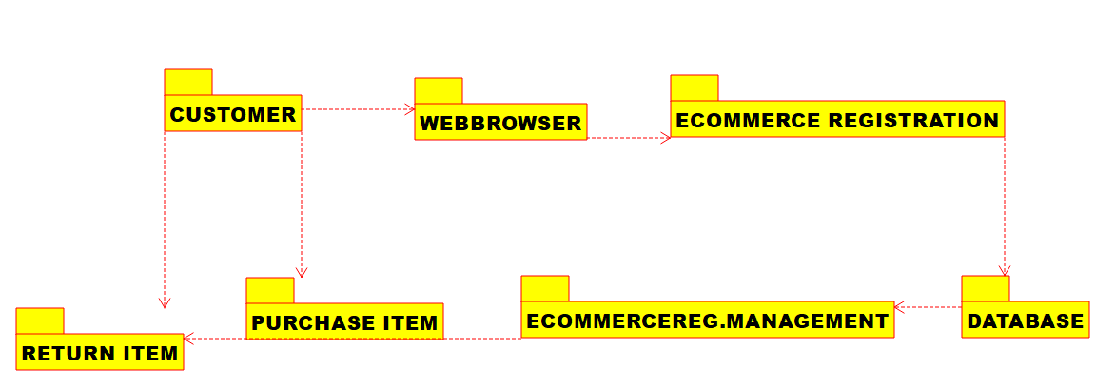

***15.AIM:-***To implement UML diagrams for Blood Bank Registration System..

***DESIGN:-***

1.USE CASE:

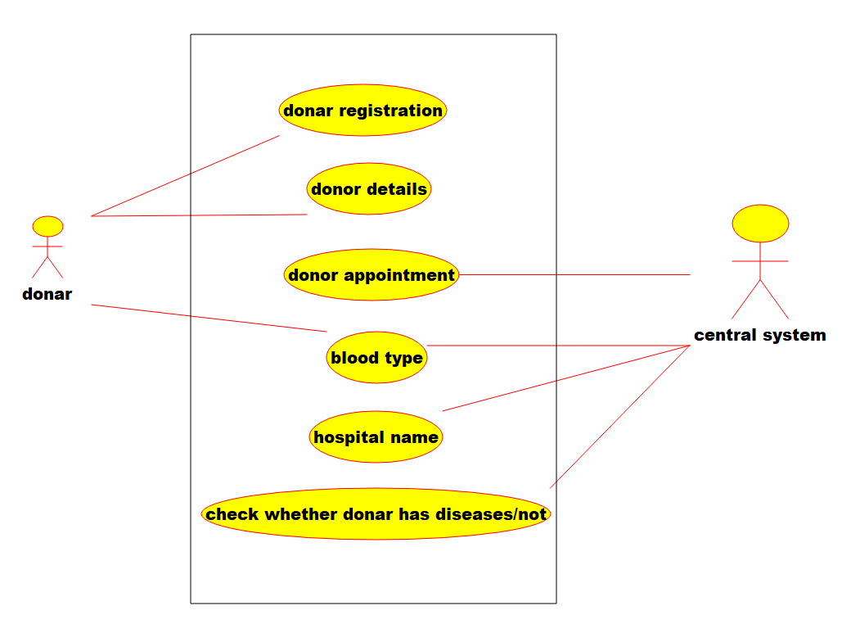

2.COLLABORATION DIAGRAM:-

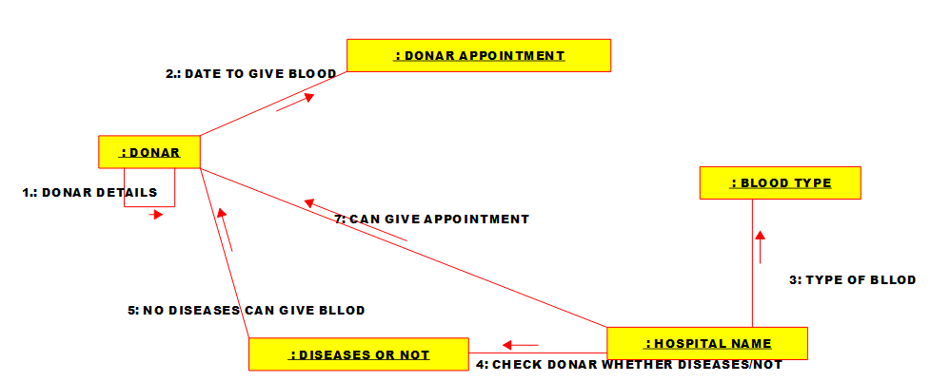

3.STATECHART DIAGRAM:-

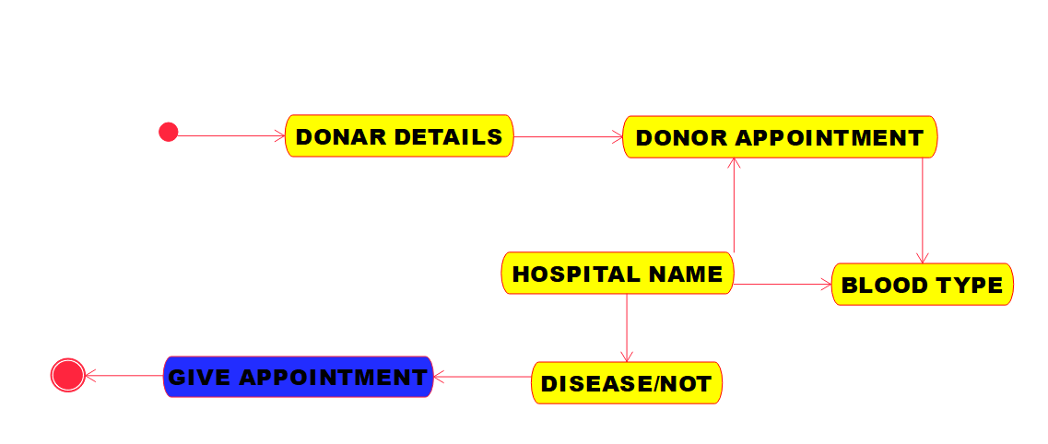

***16.AIM:-***To implement UML diagrams for Online Internship Registration System..

***DESIGN:-***

1.COMPONENT DIAGRAM:-

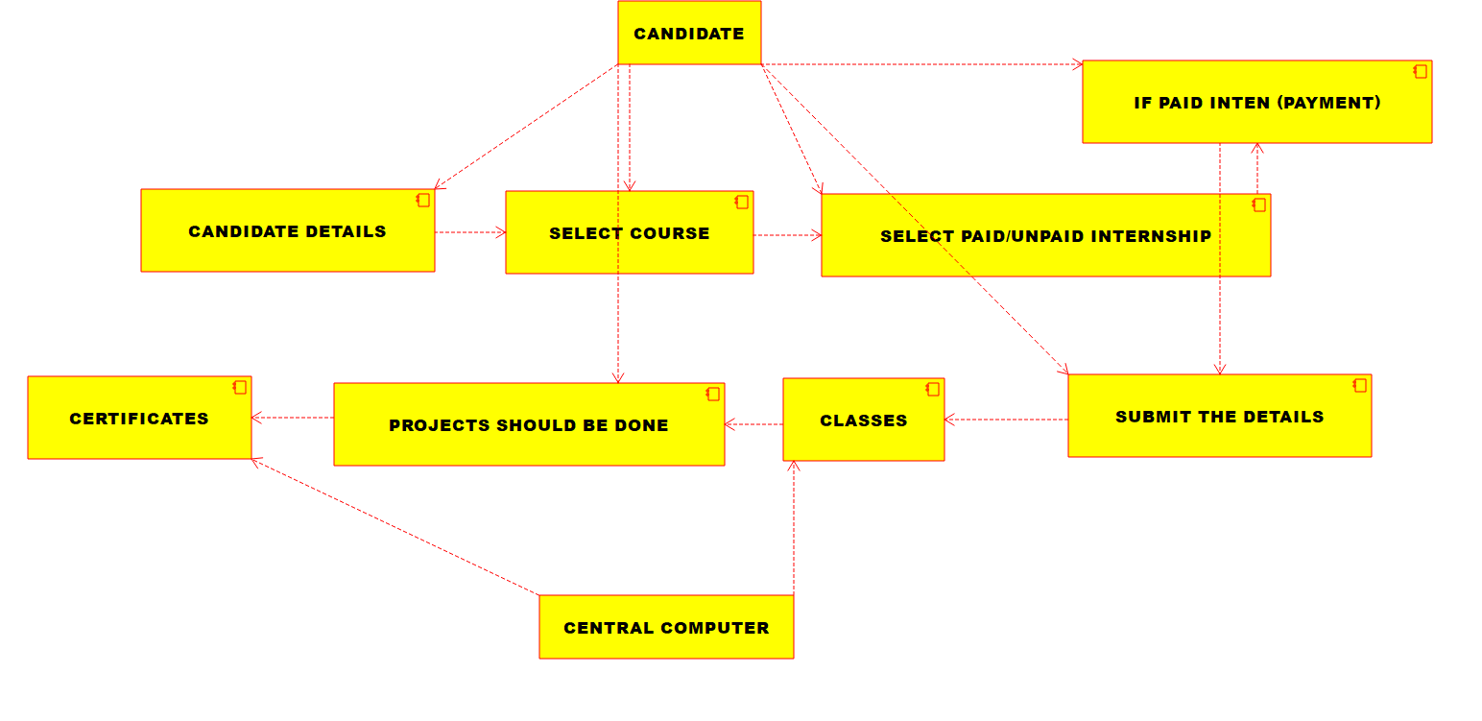

2.Deployment diagram:-

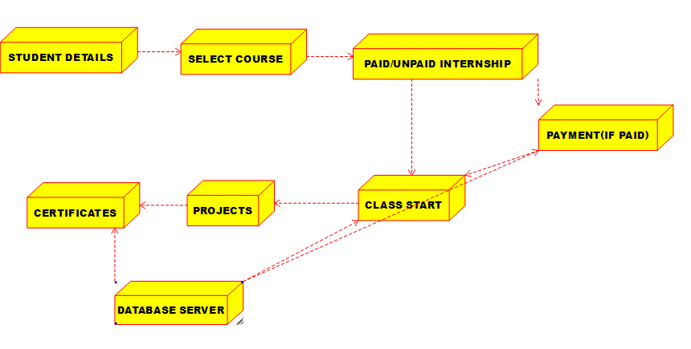

3.ACTIVITY DIAGRAM:-

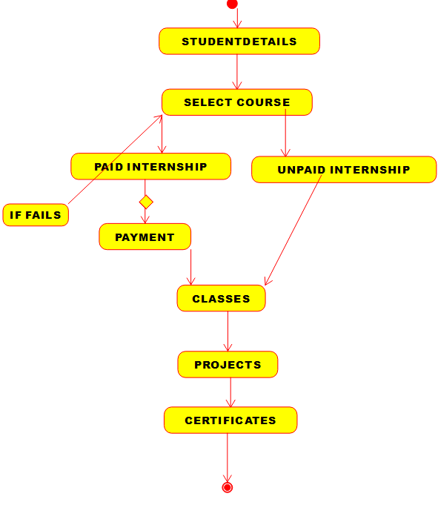

17.AIM:-To implement UML diagrams for Vehicle Registration Number Registering System…

DESIGN:-

1.SEQUENCE DIAGRAM:

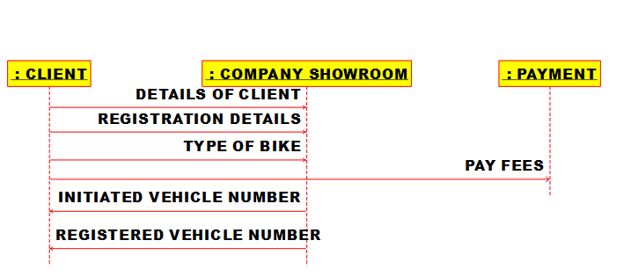

2.CLASS DIAGRAM:

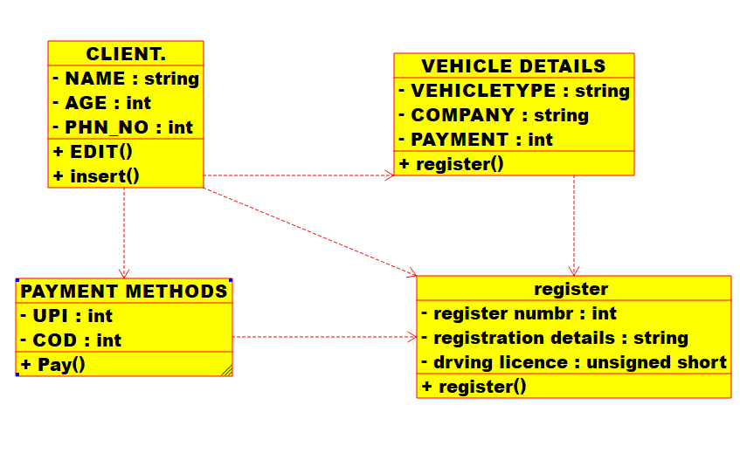

3.PACAKAGE DIAGRAM:

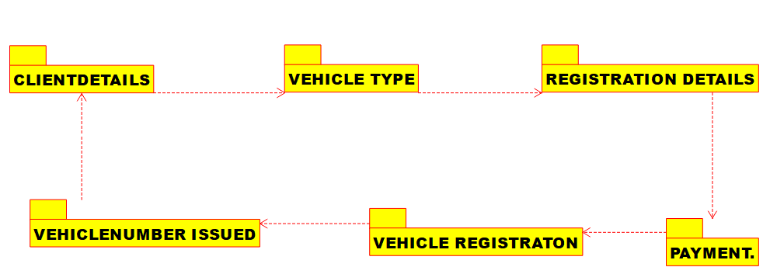

***18.AIM:-***To implement UML diagrams for FOOD ORDERING System…

***DESIGN:-***

1.USE CASE:

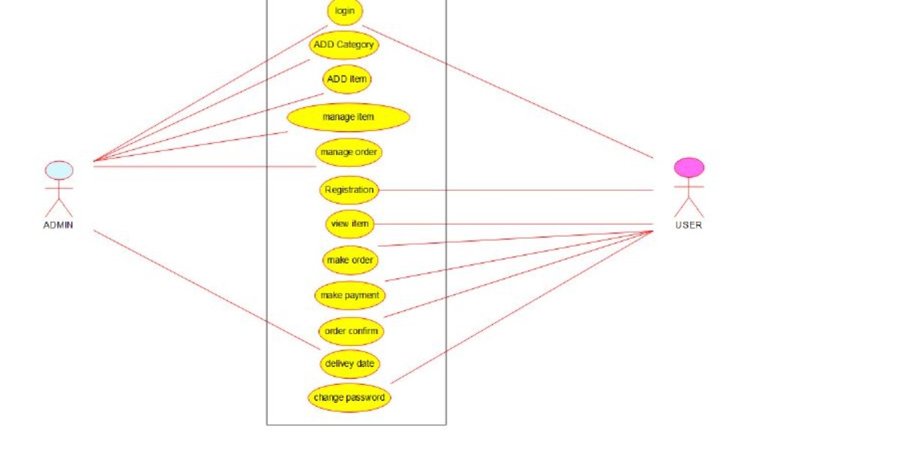

2.CLASS DIAGRAM:-

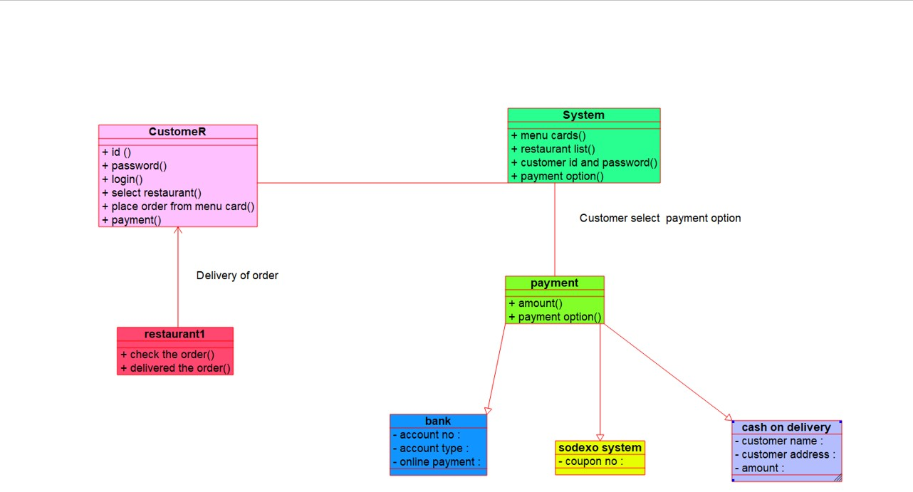

3.COLLABORATION DIAGRAM:-

